1.Draw a diagram of the OSI 7-layer model and label each layer with its correct name and a real-world example of a device or protocol that operates at that layer (e.g., Switch at Data Link, HTTP at Application).
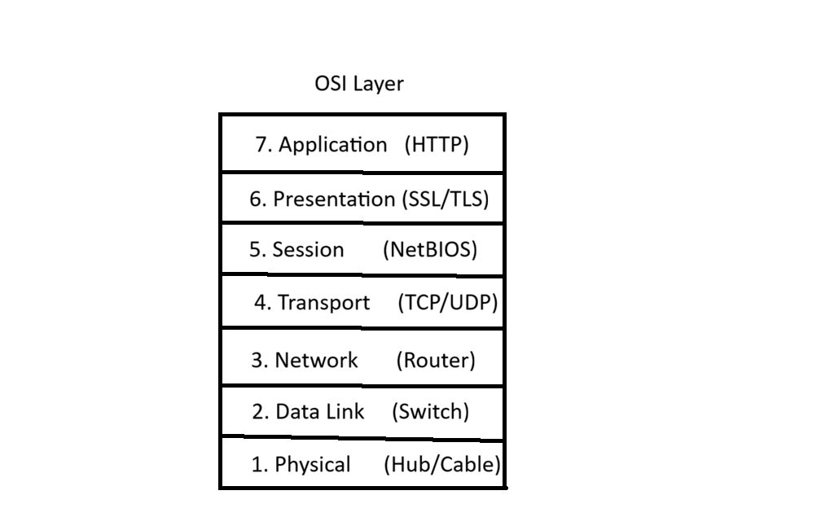
Layer | Name | Example
7 | Application | HTTP
6 | Presentation | SSL/TLS
5 | Session | NetBIOS
4 | Transport | TCP / UDP
3 | Network | Router
2 | Data Link | Switch
1 | Physical | Hub / Ethernet Cable

2.Match the following networking scenarios to the correct OSI layer: a) Encrypting data before sending, b) Routing packets across networks, c) Converting data to electrical signals, d) Opening a web page in your browser, e) Detecting and correcting errors in frames.<br><br><em><strong>Hint:</strong> Write your answers as 'Scenario: Layer Name (Layer Number)'.</em>
->a) Encrypting data before sending : Presentation Layer (Layer 6)
b) Routing packets across networks : Network Layer (Layer 3)
c) Converting data to electrical signals : Physical Layer (Layer 1)
d) Opening a web page in your browser : Application Layer (Layer 7)
e) Detecting and correcting errors in frames : Data Link Layer (Layer 2)

3.Pick any app you use daily (like WhatsApp, Instagram, or Zomato) and describe how at least three different OSI layers are involved when you send or receive data in that app.
->
4.
Given this scenario: You are unable to access a website, but you can successfully ping its IP address. Identify which OSI layer(s) might be causing the problem and explain your reasoning.

